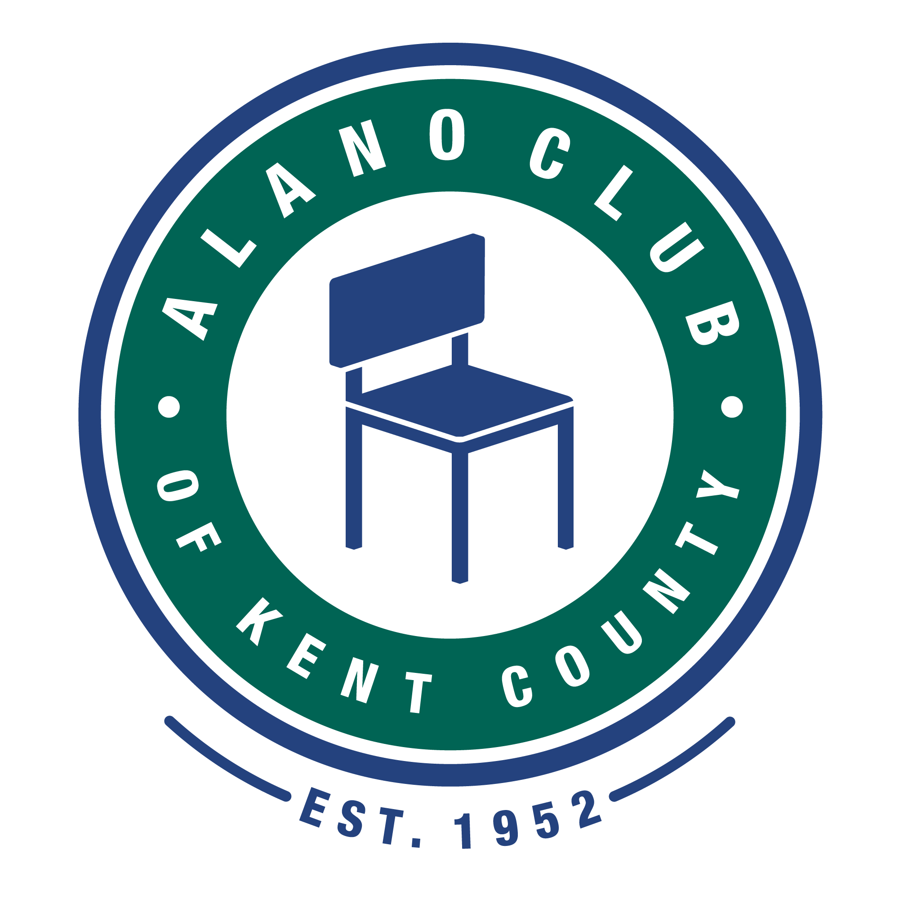
Meeting Date: 10/17/23
Meeting Start: 5:30 PM
Meeting Finish: 6:51 PM
Subject: Scheduled Board Meeting
Location: North Alano Club/ Two via ZOOM.
Attending: Elisha Ash (Chair), Brad Rose (Vice Chair), Amelia Mueller (Treasurer), Ron Schroeder (Secretary), Lauren Frazier, Mike Giusto, & Tim Coyle.
Lisa Derr (Executive Director).
[ZOOM attendees included Lauren and Mike.]
Absent: None
Minutes taken and prepared by Ron Schroeder, Secretary. [Rev.A]
Meeting Called to Order
Elisha called the meeting to order at 5:42 pm and lead a moment of silence followed by the Serenity Prayer.
Minutes Approval of the 8/15/23 Meeting
The minutes from the 8/15/23 meeting was unanimously approved.
EXECUTIVED DIRECTOR UPDATE – LISA DERR
Financial Review
Lisa presented the financial statements for the quarter ending September 30, 2023. The financials were discussed and approved after several questions were addressed.
-Discussed the financial forecasting and monthly revenue cost control efforts.
-We also discussed the asset/balance sheet not being where we would like it and agreed it needs to be reformatted. Tim agreed to take this task on.
-P&L Statement as presented was reviewed and approved by the board members.
-Additional financial comments provided by board member with CPA experience:
-Tim Coyle has been reviewing the club financial documents and providing improvements which better meet “Generally Accepted Accounting Principles (GAAP). He is also serving as an additional audit point to ensure the best financial practices. [Financial notes continued on next page]
Special Expense: Per Lisa, the existing plumbing repair of the club kitchen drains was reviewed. Several estimates and bids were considered. The vendor selected to proceed with the repairs was announced as Chad Klasko Plumbing. Costs are estimated at $2500. The board approved this project. Work should commence beginning approximately October 25th. Upon completion, the kitchen food service should be able to resume.
-It was also discussed to possibly conduct a special fundraising campaign to help with these repair costs. (One anonymous club member already has donated $1,000 to help us.)
-Additionally, the SNL speaker meeting group is providing an additional $500.00 to help cover the repair costs.

Annual Budget
There was no update to the annual budget report.

Membership Drive
There was no update to the membership drive.

Personnel Updates
Lisa provided an update on the staff headcount, no changes to report.

Events
Past recent events were reviewed as follows:
The annual Gala was completed, and the results were reviewed briefly.
Upcoming events include:
Thanksgiving and Christmas Dinners.

Old Business
Room Rents: It was discussed and agreed to increase the posted Room Rents from $35 to $40 to better offset inflation increases. The board approved this, and Lisa will have the room postings updated. Note: this is part of a larger change that will be rolled out at a later date, there are additional items included with this that are still in motion and all the details are not finalized. The vice chair will draft a letter for the board to review and comment that will be included with the pending changes.

Committees
Communications Committee
Ron continues working on the building Wi-Fi coverage.

Governance and Nominating Committee –
-Note: Tim, (Gov & Nom Committee) also provided his financial assistance to help the board comply with accounting oversight. (See comments above in Director updates.)
-It was agreed that the ballot box will not be put out this year due to having a good board size (currently seven members).
-The gov. & nom committee needs to find and vet persons with specific background experience in HR, Legal, financial, and running a business as an owner or similar level.
- A discussion was held regarding board member participation requirements per the club by-laws, and it was agreed by all to conduct appropriate enforcement of such things as attendance at board meetings and director contributions. The Vice Chair (Brad) will begin the process of enforcement as required.

Events Committee
-Lauren presented an activity to be conducted at the club which provides a fun event for members/attendees. The event will be a “Barbie” takeoff where attendees can dress up as Barbie or Ken and simply have fun celebrating the Barbie craze. This will be held in the lower level on November 3rd, beginning at 6:00pm with special activities and a special speaker panel. (The KCCO has approved this activity and any regularly scheduled meetings in this space will be relocated during this event.)

New Business

2023 Annual Membership Meeting
The Annual Meeting schedule was briefly discussed, and it was proposed by the Chair (Elisha) to conduct it during the second week of December pending scheduling reviews. A tentative date of December 16th is pending based on board member availability.

Process and Procedures

Board Meetings Frequency:
-It has been recently discussed and reviewed to modify the board meeting frequency schedule to return to the former format of monthly meetings. The number of topics and tasks required to conduct board business necessitates more frequent sessions. All members agreed to this change. Effective November 2023.
[New Business Continued]

-Lauren proposed considering conducting the added meetings as on a different time slot to make attendance easier for board members. Lauren will conduct a poll to assist with determining interest and choices in this alternative.

Board Meetings Format: It was also discussed and agreed to return to the meeting format whereby the Executive Director, upon presenting their updates and conducting Q&A time shall then be dismissed from the board meeting. This will allow the board to review and conduct business as a confidential process. Board meetings are to be limited to one- and one-half hours. Effective November 2023.

Executive Director Coaching: The board recently engaged an outside professional business coach to provide guidance and skills development for the Executive Director and further guidance to the board as well. Topics include setting critical strategic goals, non-profit mission statements, etc.

Adjournment

The meeting was adjourned at 6:51 pm.

Next Meeting
The next Board Meeting is scheduled for 11/21/23. (Time and format to be determined.) Please mark your calendars.

