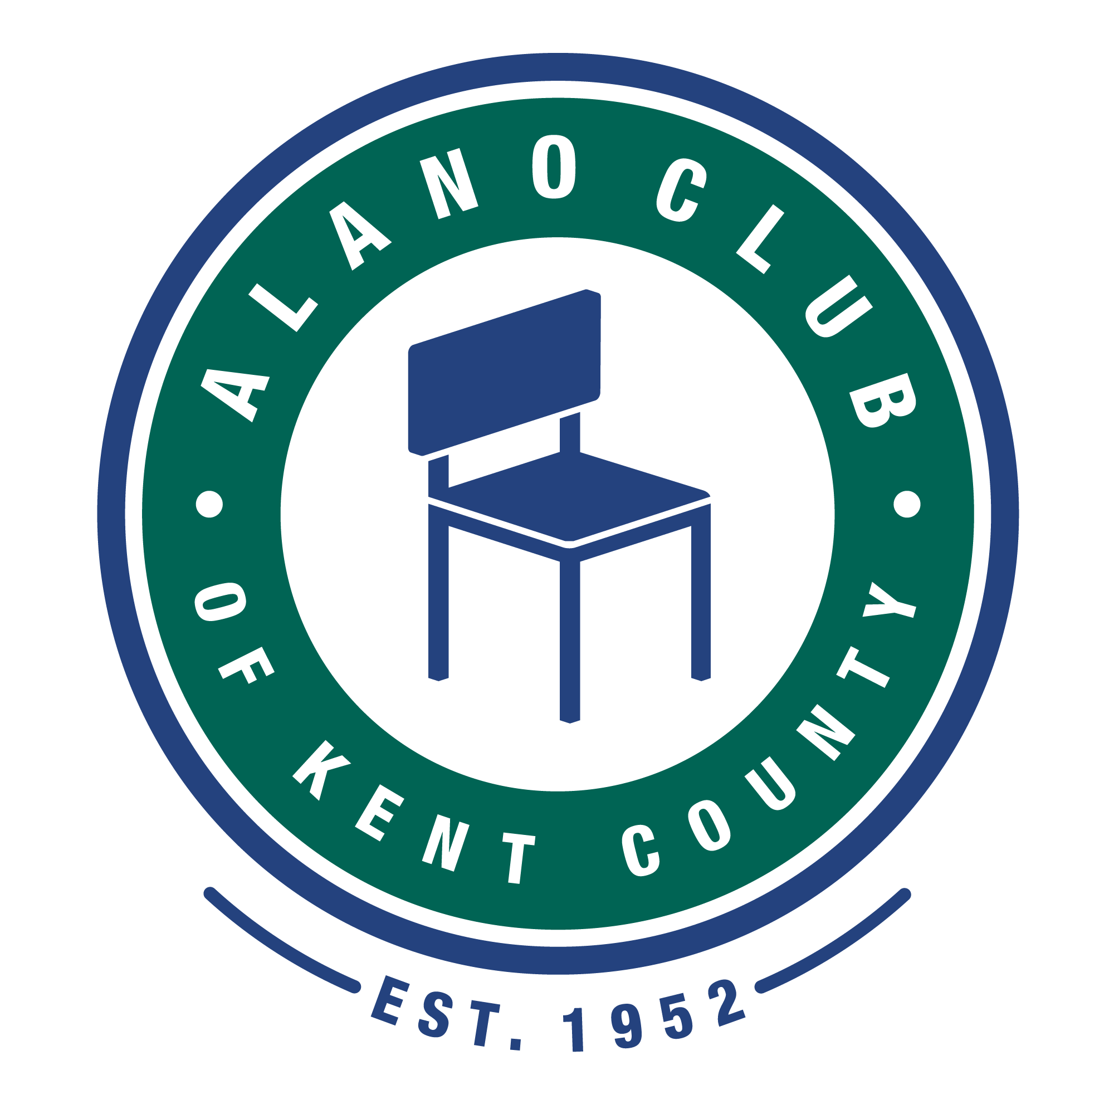
Meeting Date: 11/21/23
Meeting Start: 9:00 AM
Meeting Finish: 9:55 AM
Subject: Scheduled Board Meeting
Location: VIA ZOOM.
Attending: [ZOOM] Elisha Ash (Chair), Brad Rose (Vice Chair), Amelia Mueller (Treasurer), Ron Schroeder (Secretary), Mike Giusto & Lisa Derr (Executive Director).
Absent: Lauren Frazier, Tim Coyle.
Minutes taken and prepared by Ron Schroeder, Secretary.

Meeting Called to Order
Elisha called the meeting to order at 9:05 am and lead a moment of silence followed by the Serenity Prayer.
Minutes Approval of the 10/17//23 Meeting
The minutes from the 10/17/23 meeting was unanimously approved.

EXECUTIVE DIRECTOR UPDATE – LISA DERR
Financial Review
Lisa presented the financial statements for September/October 2023. The financials were discussed and approved.
-P&L Statement as presented was reviewed and approved by the board members.

Special Expense: Per Lisa, the existing plumbing repair of the club kitchen drains was completed allowing the reopening of the café. Costs were estimated at $2500, and completion totaled $3500.
-It was also discussed to possibly conduct a special fundraising campaign to help with these additional repair costs, including restoration of the finished floor.

[Financial review continued next page.]

Events Financials
The 2023 Gala event yielded a net profit of $12,999. There were 90 registered guests of which 79 attended.
The Barbie event was well attended and created and hosted by our Lauren Frazier. This event yielded a net profit of $728. $150 of the gross revenue was directed to pay for the baby changing station recently installed in the lower-level men’s room.
The Grand Reopening of the café event yielded a net profit of $2,164.

Annual Budget
There was no update to the annual budget report.

Membership Drive
There was no update to the membership drive.

Personnel Updates
There was no update on personnel.

Events
Past recent events were reviewed as follows:
The annual Gala and the Barbie event were reported as successful. (See specific financials in the Directors report above.)
Upcoming events include:
Thanksgiving and Christmas Dinners.
- Volunteers and donations are progressing well for the Thanksgiving dinner event.
The Annual Membership Meeting is scheduled for December 16, 2023, at 1:30 pm-3:30 pm.

Old Business
No old business was discussed.

Committees
Communications Committee
Ron continues working on the building Wi-Fi coverage.
Governance and Nominating Committee
[See the discussion below on the upcoming annual membership meeting regarding changes in the nominating procedures.]
Events Committee
No further updates on events currently.

New Business

2023/2024 Snowplowing/Salting Service
Parking lot 2023/2024 snow plowing and salting bids are being sought with a competitive bid from a qualified contractor nearing approval.

Concourse “Bricks”
Lisa advised that there has been a member inquiry regarding adding bricks to the concourse to honor past members/attendees. It was suggested to check with Kris T. and Beldin Brick company to see what might be possible.

2023 Annual Membership Meeting
The Annual Meeting schedule was again discussed, and it was confirmed to be held on Saturday, December 16, 2023, at 1:30 pm at the North Club balcony. This is limited to active paid members. [Note: See procedure change below.]
Also discussed and agreed upon is to schedule a “Town Hall” meeting for members and attendees to discuss the many activities of the North Club and potentially serve to enhance our board member recruiting efforts. This would be planned for a date in the 1st Quarter of 2024.

Process and Procedures
By unanimous vote, it was agreed that no new nominations will be conducted for this year’s annual meeting. Elisha will be preparing verbiage to explain this action that will be included in meeting announcements. The intent here is to improve our board member recruiting criteria to better meet the needs of the ACKC going forward.

Adjournment

The meeting was adjourned at 9:55 am.

Next Meeting
The next Board Meeting is scheduled for 12/19/23 at 5:30 pm onsite at the North Club.

