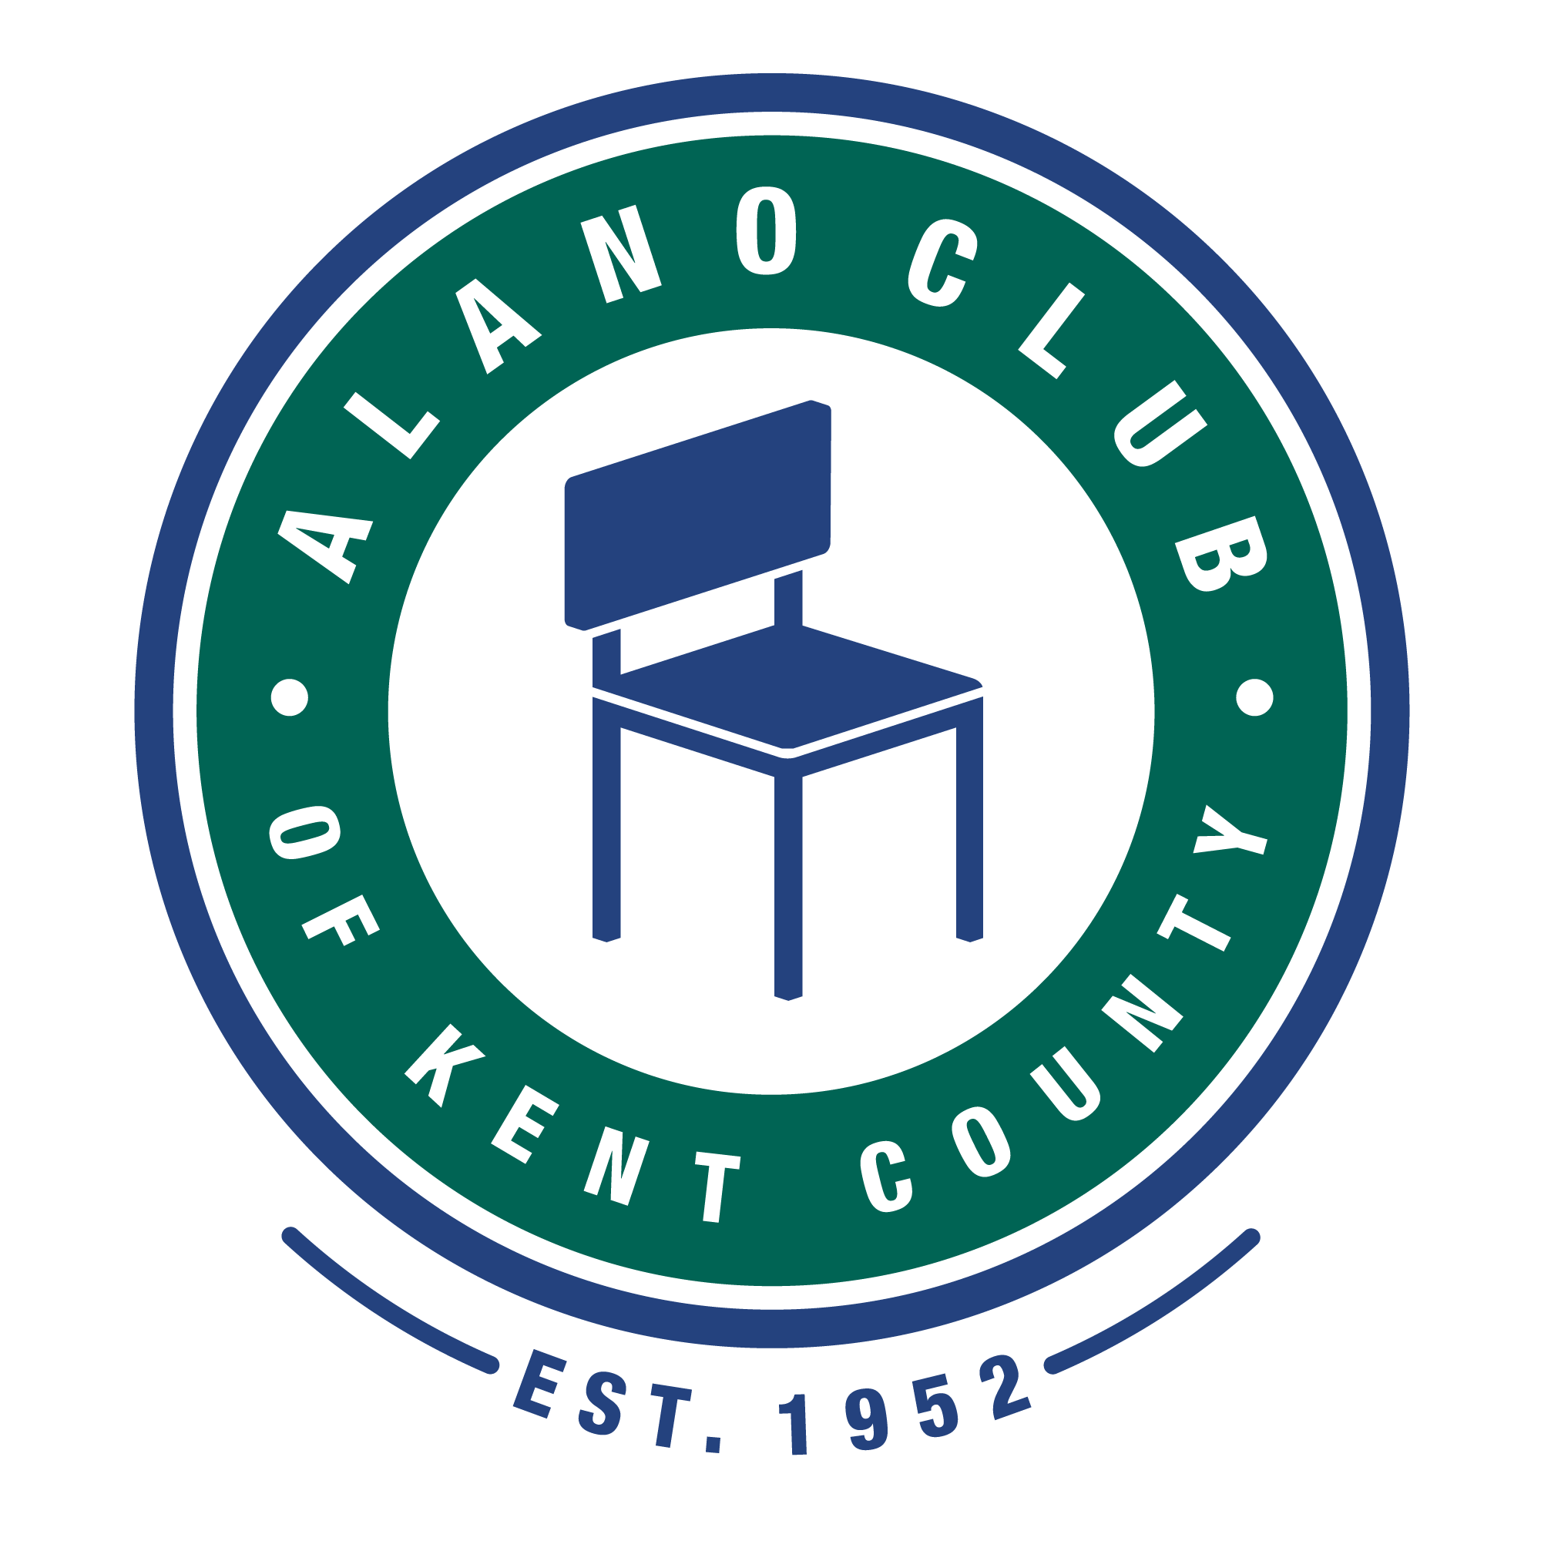
Meeting Date: 8/15/23
Meeting Start: 5:30 PM
Meeting Finish: 6:35 PM
Subject: Scheduled Board Meeting
Location: North Alano Club/ Three via ZOOM.
Attending: Elisha Ash (Chair), Brad Rose (Vice Chair), Amelia Mueller (Treasurer), Ron Schroeder (Acting Secretary), Lauren Frazier, Mike Giusto,
Lisa Derr (Executive Director).
[ZOOM attendees included Brad, Amelia, and Lauren. Connection was lost before meeting ended so no Quorum was reached which postponed certain decisions.]
Absent: Tim Coyle, Erica Eldred,

Meeting Called To Order
Elisha called the meeting to order at 5:35pm and lead a moment of silence followed by the Serenity Prayer.
Minutes Approval of the 6/20/23 Meeting
The minutes from the 6/21/22 meeting was unanimously approved.

EXECUTIVED DIRECTOR UPDATE – LISA DERR
Financial Review
Lisa presented the financial statements for the quarter ending June 30, 2023. The financials were discussed and approved after several questions were addressed.
-Questions were related to the financial forecasting and monthly revenue requirements.
-Lisa explained she needs some help with financial forecasting.
-Amelia offered to assist Lisa with a plan to develop a forecasting process.
Annual Budget
There was no update to the annual budget report. (See above note on forecasting.)
Membership Drive
There was no update to the membership drive.
Personnel Updates No updates were provided.

Events
Past recent events were reviewed as follows:
-Recovery Bike Run on June 24th. Response was approximately 35 and was considered reasonably successful.
-Golf Outing in August was successful with 120 golfers. Total profit reported as estimated $11,576.86, a significant increase over the prior year 2022.
The upcoming events include:
-AA Safety Panel on Friday, September 8th, 5:30-7:00pm.
-A Night with Friends-Concert on Friday, September 15th, 5:00-10:00pm.
-Two concert bands, free coffee, food truck, etc. 10% of profit will come back to the Alano club.
-The Annual Fall Gala is scheduled for October 16, 2023.
2023 Gala Keynote Speaker
Alano Club of Kent County’s 2023 Gala keynote speaker this year will be Steve Kelly from WOOD Radio. Don’t forget tickets are on sale now at www.gralanoclub.org/events or click the bottom below.
Individual tickets are $100 per person, and sponsorship opportunities are still available. If you are interested in becoming an event sponsor, please See our Executive Director, Lisa Derr, or email her at lderr@gralanoclub.org

Old Business
Baby Changing Station
-Per Lauren’s initiative, the proposed addition of a baby changing station for the lower-level men’s room has been approved and is proceeding. Lisa has ordered a station for $150 and will be making arrangements to have it installed by a club member at no cost.
Also, a fundraising effort lead by Lauren will be made to help offset the cost.

Committees
Communications Committee
Ron reported that he is now in the process of analyzing and initiating steps to improve the building Wi-Fi coverage and capacity.

Governance and Nominating Committee – Annual elections are coming up and need to be scheduled. [As no quorum was met at this meeting, it will need to be discussed at the next meeting in October. See note below.]

Events Committee
No further updates were discussed.

New Business
Cost Savings Suggestion:
-Lauren suggested that the Alano Club explore the possible consolidation of vendor suppliers to optimize any possible discounts or price matches that might be derived. After a lengthy discussion, Mike agreed to discuss this with Megan.

Process and Procedures

Special Note: Since a Quorum was not met at this meeting it was agreed that Elisha would follow up with email survey(s) to provide board member voting on certain items which still need to be decided. These may include Board Composition including attendance requirements and compliance, restoral of board meetings to a monthly schedule, dismissal of Executive Director after their update segment during board meetings, and scheduling of a meeting to plan the upcoming annual membership meeting and board elections.

Adjournment

The meeting was adjourned at 6:35 pm.

Next Meeting

The next Board Meeting is scheduled for 10/17/23. Please mark your calendars.

