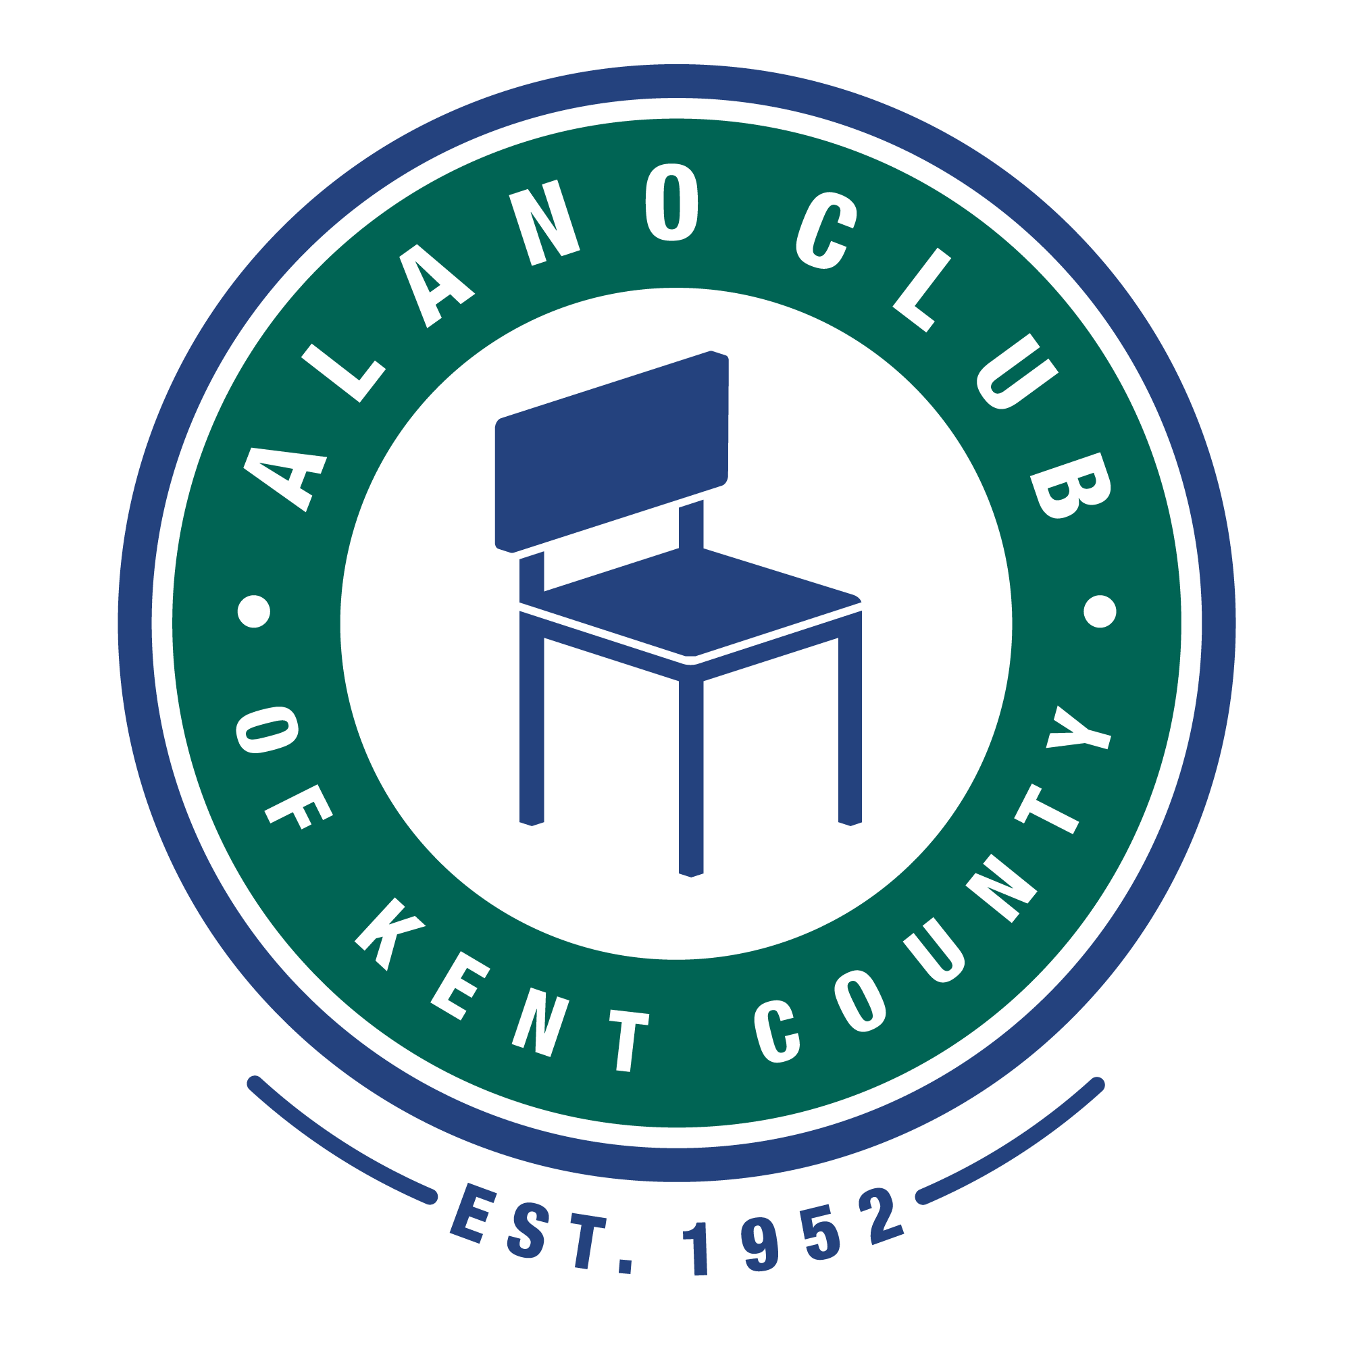
Meeting Date: 10:18;22
Meeting Start: 5:46 PM
Meeting Finish: 7:22 PM
Subject: Scheduled Board Meeting
Location: North Alano Club/ZOOM
Attending: Elisha Ash (Chair), Brad Rose (Vice Chair), Maggie Stalker, Ken Derylo (Secretary), Lisa Derr (Executive Director), Lauren Frazier, Amelia Mueller (Treasurer)
Absent: Mike Baker, Mike Giusto, Erica Eldred

Meeting Called To Order

Elisha called the meeting to order at 5:46pm and asked for a moment of silence followed by the Serenity Prayer.

Minutes Approval of the 8/16/22 Meeting

The minutes of the 8/16/22 meeting were unanamously approved.

Don Nicewinder Announcement

Elisha informed the board that Don Nicewinder was moving to Florida and has resigned. With Don resigning and Maggie’s term expiring we will no longer have an attorney on the board. Amelia stated that she would share some contact information on some potential legal people who may be willing to help out the Alano Club.

Many thanks to both Don and Maggie for thier contributions especially with re-writing the by-laws.

EXECUTIVED DIRECTOR UPDATE – LISA DERR

Financial Review

Lisa presented the financial statements for the quarter ending September 30, 2022. This included the P&L for the quarter, the Balance Sheet and the P&L comparisson for the year. It was pointed out that one of the line items related to the golf outing report did not match the amount reported on the P&L. Lisa mentioned that this was an error and she would make the correction. Amelia motioned to accept the finacial report with the correction and this was seconded by Brad. This motion was passed without objection.

There was a discussion regarding placing some of the clubs funds into some form of an interest baring account. It was mentioned that the savings should not be put into the edowmwnt fund. Elisha stated that she would follow up with Bob Krepps to get his input.

Annual Budget

There was no update to the annual budget report.

Membership Drive

Nothing new to report. This is an ongoing effort and membership has increased since it began.

Events

The club's 70th birthday celiration was held on 9/9/22 and included a Spaghetti DInner. The event was well attended and donations of $726.15 were received. Expenses totaled $31.96 (the food for the dinner was donated).

The annual Gala was held on 10/4/22. Ken Daniels was the guest speaker and the event was well attended. The finacials for this event have not been completed as donations are still trickling in. A question came up regsrding to receiving a discount from GVSU if we were to pay them up front. Lisa will be checking with them to see if this is possible.

There will no Town Hall meeting this year.

The upcoming events include:

Thursday, October 20th, 2:30 – 3:00 in the café – ALL STAFF - Pine Rest Presentation.
Thursday, October 27th – Al-Anon Banquet 5:30p – 8:00p Balcony
Friday, October 28st – Pulaski days Meal – 11am – 2:00pm
Saturday, October 29th – Young People Halloween Party Balcony 7p-12a.
October – Members Meeting?
November 6th – David Olsen Memorial – 11:30a – 2:30p Balcony.
November 11th – KCCO Fall Event – 6p – 9p Balcony.
November – End of Year Giving
Thursday, November 24th – Thanksgiving Dinner
Sunday, December 25th – Christmas Dinner
Saturday, December 31st – Men’s Gratitude Luncheon – Balcony 11a – 3p.

Personnel Updates

Lisa informed the board that there was a new staff memebr - Luke - who will be working weekends along with Monday and Tuesday nights.

Building Repair

There was no update provided on the door replacement other than it has not been completed.

Other

Lisa had no other items to report.

BOARD CHAIR UPDATE - Elisha Ash

Committees

There were no commitee updates.

Recognition

Elisha pointed out that Maggie’s term is expring and that she is not eligibal to run again and she was thanked forher service. Maggie volunteered future services going forward if needed.

Bylaw Changes

There was a brief discussion on changing the bylaws to read if a board member misses two consecutive meetings that they would be removed. It was determined that no chnages were needed.

Members Meeting

The annual members meeting and elections will be help on Saturday, December 3, 2022. This will be a hybrid meeting and the ZOOM info will be published. Members can start to sign in at 1:30pm. With the meeting starting at 2pm. The meeting will last as long as needed. Memebers will be voting on new board members. There are currently 3 openings on the board.

Prior to the members meeting there will be a board meeting – also a hybrid meeting – from noon to 1pm.

Adjournment

The meeting was adjourned at 7:22pm.

Next Meeting

The next Board Meeting is scheduled for 12/3/22 at noon. Please mark your calendars.

