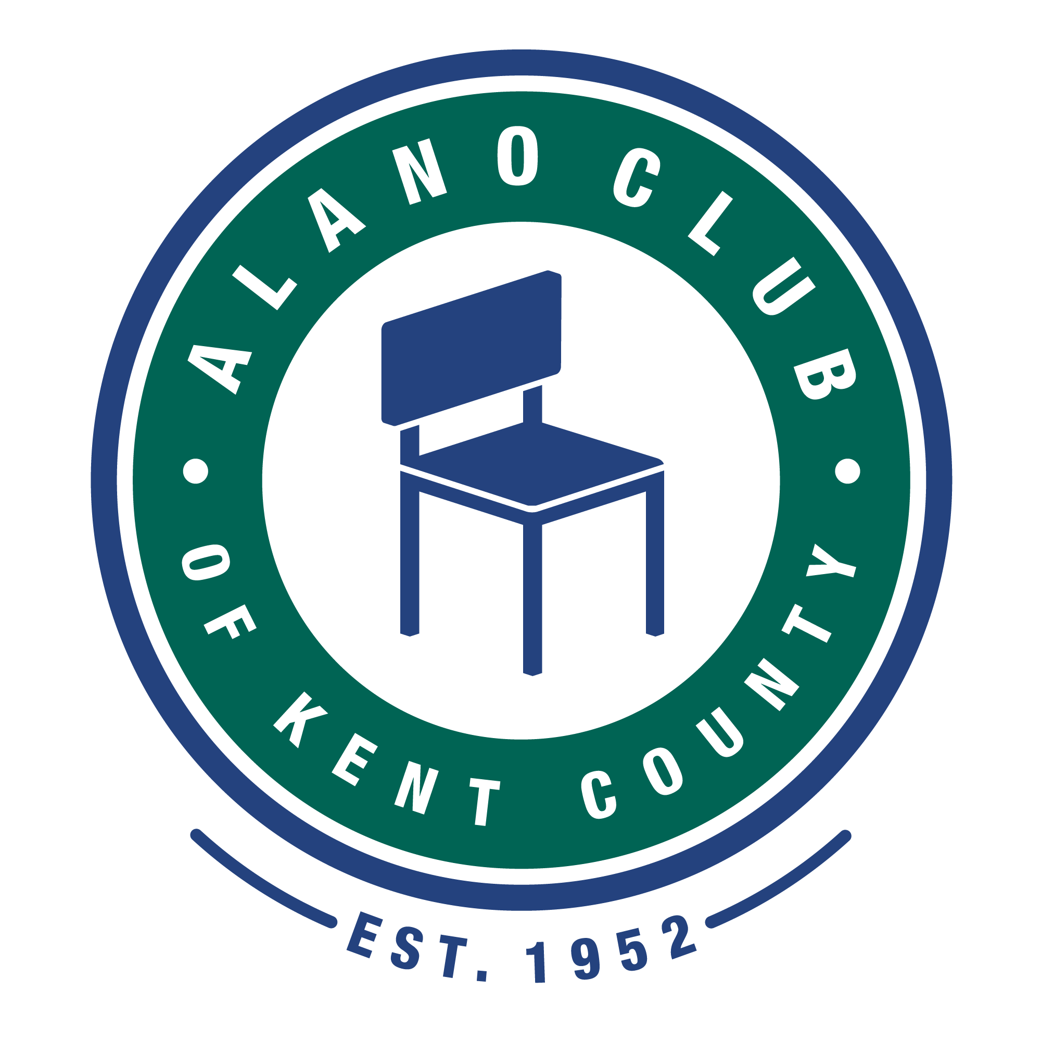
Meeting Date: 8/16/22
Meeting Start: 5:30 PM
Meeting Finish: 7:10 PM
Subject: Scheduled Board Meeting
Location: North Alano Club/ZOOM
Attending: Elisha Ash (Chair), Brad Rose (Vice Chair), Maggie Stalker, Ken Derylo (Secretary), Lisa Derr (Executive Director), Lauren Frazier, Mike Giusto, Erica Eldred

Absent: Mike Baker, Don Nicewander, Amelia Mueller (Treasurer),

Meeting Called To Order

Elisha called the meeting to order at 5:30pm and asked for a moment of silence followed by the Serenity Pray.

Minutes Approval of the 6/21/22 Meeting

The minutes from the 6/21/22 meeting were unanimously approved.

EXECUTIVED DIRECTOR UPDATE – LISA DERR

Financial Review

Lisa presented the financial statements for the quarter ending June 30, 2022. The fina
Were approved without questions.

Annual Budget

There was no update to the annual budget report.

Membership Drive

This is an ongoing effort and there has been an increase in membership since this effort started.

Increased Exposure – Increased meeting Attendance

4 new meeting requests have been submitted and are being reviewed. Lauren suggested reaching out to local businesses and organizations letting them know some of the services we provide. This would start by creating a list of “target organizations”. Lisa stated that a list is being developed by herself and Tim and they have reached out to some on the list. Lisa also mentioned that tours are on the rise.

Events

Two scheduled events, the Red White and BBQ and the annual Golf Outing, were held. The BBQ netted $80.00 and the Golf outing netter over $10k. These numbers are not final, but the results should be close.

The upcoming events include:

The Club’s 70th Birthday Celebration that will take place on September 9, 2022. This will include a Spaghetti dinner that will be served from 11:00am – 2:00pm. As always, donations will be appreciated.

The Annual Fall Gala that is scheduled for October 4, 2022. Tim mentioned that there is a meeting scheduled with the Event Committee on August 22 to discuss last minute concerns. It was mentioned that the Venue and Menu are set. Also, the guest speaker, Ken Daniels, has also been signed up. There are some questions with the introductory video that Ken sent and that is being addressed.

Personnel Updates

There were no staff changes reported.

Building Repair

The proposal to complete the repairs on the doorway near room 4 have been accepted. Brad said he would let Megan know to move forward.

Other

Lisa reported that a Christian Rock performer, Zach Williams will be performing at the DeVos Performance Hall on September 18. As part of his program, Zach selects a charitable organization and donates $2,500.00 to them. The ACKC has been selected as the charity and will be presenting the check to the club at this performance. Lisa mentioned that all board members can attend at no cost.

BOARD CHAIR UPDATE - Elisha Ash

Committees.
Communications Committee – As previously reported, Lauren suggested reaching out to local business and organizations to help improve visibility of club and to let them know what we have to offer.

Governance and Nominating Committee – Annual elections are coming up and need to be scheduled. Brad mentioned that there was some interest on the part of the membership to run for one of the 4 open positions. Mike G. volunteered to serve on the election committee.

Events Committee – A meeting has been scheduled for 8/22 to discuss progress and what needs to be done for this event. One of the items being looked at are Gift Bags for all who attend as a way of thanking them for their support.

Financial Audit

It was pointed out that it has been almost 4 years since our last audit, and it was agreed to looking into having one completed. Brad said he would look into this and get some quotes on what this might cost. It was also mentioned that it might be wise for the Governance Committee to add this to the Bylaws.

Process and Procedures

It was pointed out that we documentation and procedures for many of the functions that happen at the Club. Lisa mentioned that she and her staff would be working on this documentation.

Adjournment

The meeting was adjourned at 7:10pm.

Next Meeting

The next Board Meeting is scheduled for 10/18/22. Please mark your calendars.

