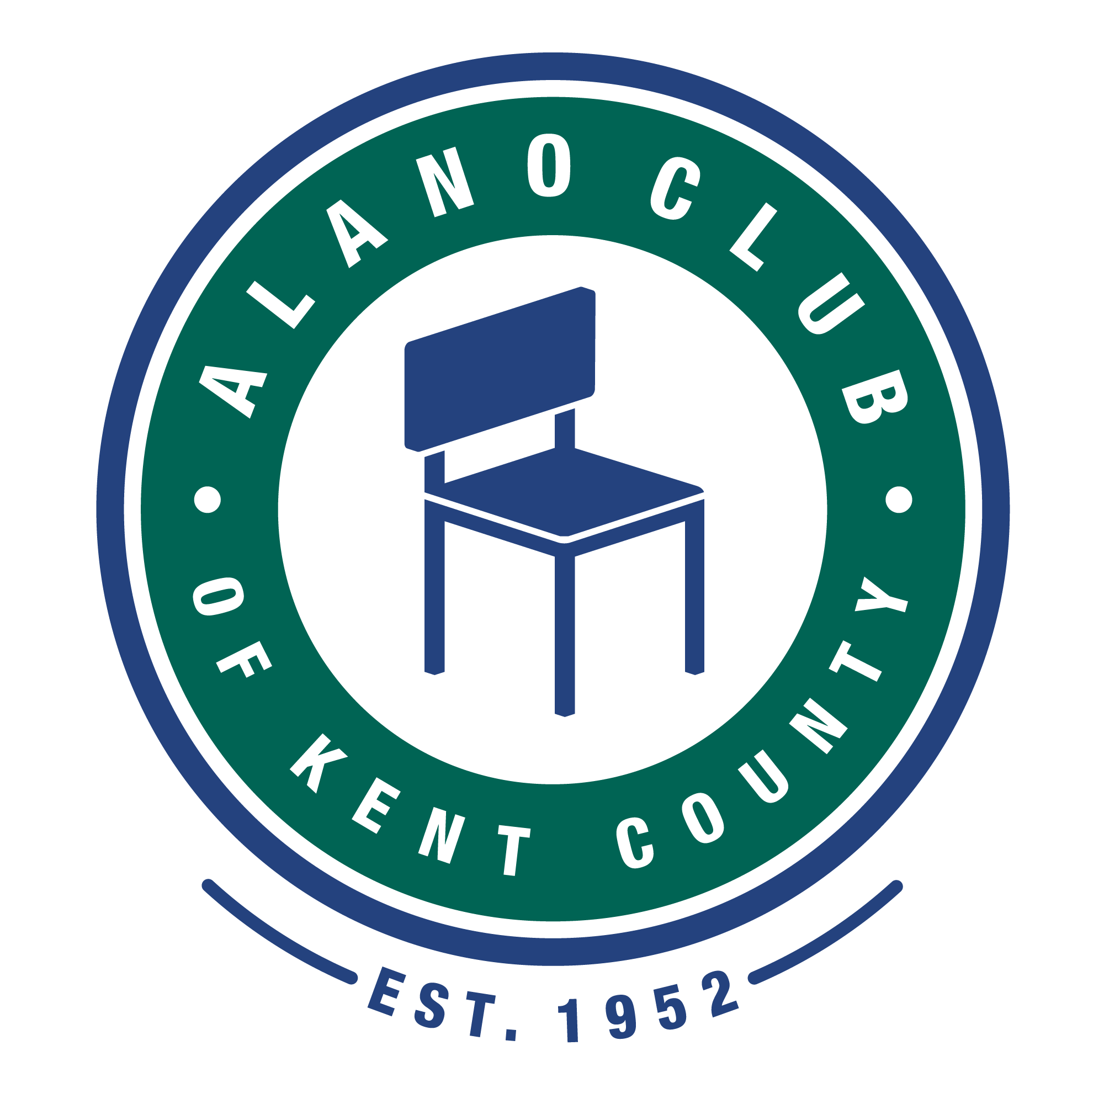
Meeting Date: 6/21/22
Meeting Start: 5:30
Meeting Finish: 7:15 PM
Subject: Scheduled Board Meeting
Location: North Alano Club/ZOOM
Attending: Elisha Ash (Chair), Mike Baker, Brad Rose (Vice Chair), Maggie Stalker, Ken Derylo (Secretary), Amelia Mueller (Treasurer), Lisa Derr (Executive Director),

Absent: Mike Giusto, Lauren Frazier, Don Nicewander, Erika Eldred

Meeting Called To Order

Elisha called the meeting to order at 5:30pm and asked for a moment of silence followed by the
Serenity Pray.

Board Only Discussion

A brief discussion with the board members present was held and Elisha stated that we need a mechanism for members to contact the executive board and express concerns. The thought is to have a link the club website where members could go to to express their concerns/grievances and questions. A process would need to be put in place for the grievances/questions to be addressed and communicated to the member(s). It was determined that this should be something that the Communications Committee should develop.

Minutes Approval of the 4/19/22 Meeting

Ken motioned that the minutes from the 4/19/22 meeting be approved. This was seconded by Amelia. and were unanimously approved.
Megan Gogo Presentation

Megan gave a presentation outlining the food costs. This provided a per serving breakdown for most food items being sold on the club cafeteria. This information presented is a result of a food expense system that is being developed with Gordon Foods. It was pointed out that non-Gordon Food items can be inputted into the system.

Megan also shared the latest Kent County Health Dept. inspection report and all is good.

Megan information on the water damage and the cost to repair this damage. It was pointed that repair guarantees were needed before approval. In addition, Megan reported that a dehumidifier was purchased to help with the water and wetness problem. This appears to be helping. Bad mentioned that the building should be inspected every two years.

Finally, it was mentioned that the parking lot was being patched using community services resources. These patches seem to be adequate.

Many thanks to Megan for her presentation.

EXECUTIVED DIRECTOR UPDATE – LISA DERR

Financial Review

The questions regarding the 4/16/22 Financials have been adequately answered and the reports have now been approved.

Lisa stated that she would like to do the financial reporting on a quarterly basis. It was mentioned that this should be added to the bylaws and would require boars approval.

It was mentioned that financial reports should be sent out as soon as they are ready so the board has a chance to review prior to the board meeting.

Amelia motioned to approve the financial reports presented. This was seconded by Brad and the financial report was approved.

Annual Budget

There was no update to the annual budget report.

Spring Table Luncheon (Round Table)

The results of the Spring Table Luncheon were presented. After expenses, this fund raiser had a net profit of $2563.36.

Membership Update

It was reported that the total membership as of June 1 stands at 327. Hopefully these increases will continue.

Red/White and Bar-B-Q

This annual event is on for July 9 and will include Music and Face Painting. As always, donations for this event are welcomed.

Golf Outing

This event will be held on Saturday July 30 at Scott Lake Country Club. This year, for safety reasons, riding around the course on golf carts selling raffle and promo items will not be allowed. Volunteers and staff can be stationed at holes (preferably the tee areas) to facilitate this. An emphasis on sales before teeing off will be emphasized.

Other

Lisa mentioned that Kyle and John have joined the staff. Kyle is working first shift Monday – Friday and John os working weekends and Monday and Tuesday nights.

It was mentioned that Guiding Light is now a Community Partner.

No real updates on the Fall Gala. Everything appears to be on track for this event.

BOARD CHAIR UPDATE - Elisha Ash

Committees.

Once again Elisha mentioned that there is a need for committee chairs and they need to establish agendas. She mentioned that the committees need to step up.

Adjournment

Ken motioned that the meeting be adjourned and was seconded by Amelia. The motioned was unanimously approved and the meeting adjourned at 7:15pm.

Next Meeting

The next Board Meeting is scheduled for 08/16/22. Please mark your colanders.

