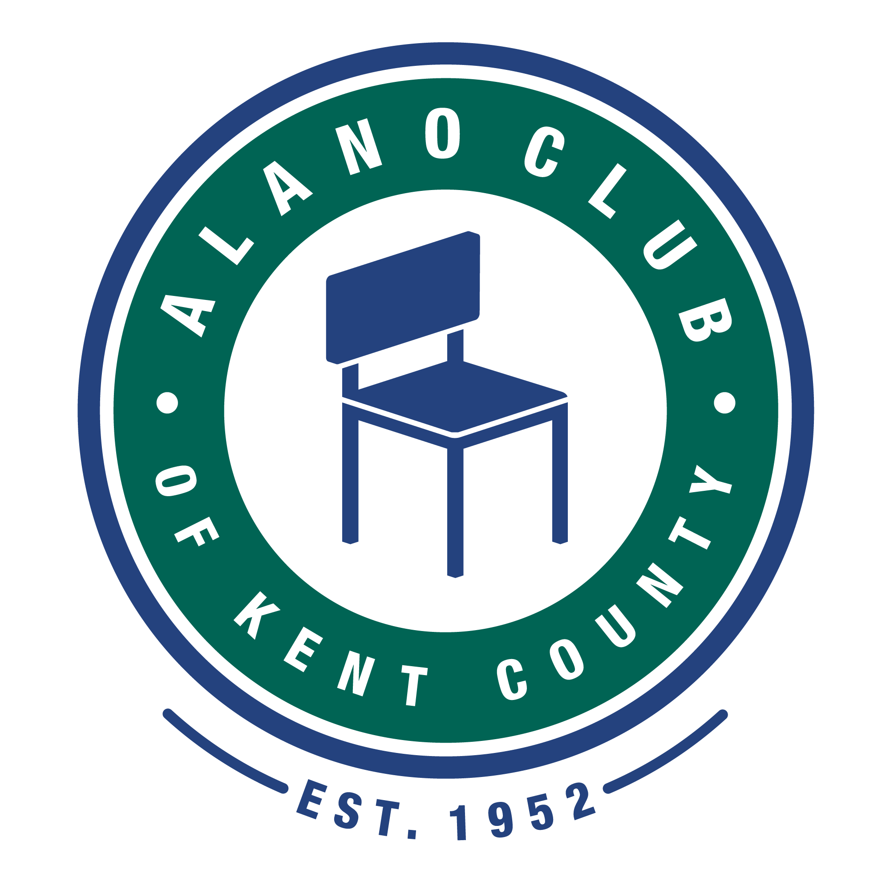
Meeting Date: 4/19/22
Meeting Start: 5:30
Meeting Finish: 7:03 PM
Subject: Scheduled Board Meeting
Location: North Alano Club/ZOOM
Attending: Elisha Ash (Chair), Mike Baker, Brad Rose (Vice Chair), Maggie Stalker, Ken Derylo (Secretary), Amelia Mueller (Treasurer), Lisa Derr (Executive Director), Mike Giusto,
Lauren Frazier, Don Nicewander

Absent:

Meeting Called To Order

Elisha called the meeting to order at 5:30pm and asked for a moment of silence followed by the
Serenity Pray.

Minutes Approval of the 2/15/2022 Meeting

Ken motioned that the minutes from the 2/15/22 meeting be approved. This was seconded by Mike G. and were unanimously approved.

Tim Dolphin – With Pine Rest Presentation

Tim Dolphin gave proposal on a partnership with Pine Rest. The purpose of this program is to bring to the club more speaking events with a focus on mental health issues. The presentations would be given by trained professionals who are well versed in the topic that they would be discussing. The program includes training for Alano Club employees as well as 4 sessions for members who would like to attend. The list of sessions is lengthy (See Pine Rest Training Catalog) and includes such topics as Depression, Grief, Managing Worry and Anxiety, etc. The cost to the Alano Club would be $208.00 and includes the employee training and 4 speakers sessions open to club members.

Erica E. questioned bringing in outside speakers as this brings up anonymity concerns. It was pointed out that the speakers are trained professionals who work in the recovery business and they would value a persons privacy (NOTE: Since this presentation, a privacy statement was created to help protect the identity of those attending).

The cost of the program was also questioned and Tim was asked to verify all cost before the board was asked to approve this program. (NOTE: Tim has verified the cost and the $208.00 is the correct amount).

EXECUTIVED DIRECTOR UPDATE – LISA DERR

Financial Review

Lisa presented the latest financial (Profit & Loss) statement for December 2022 through February 2022. The report states that expenses outpaced revenues by $396.00. However, there appears to be errors on what was stated on accounts 5430-4 - Thanksgiving Event Expense and 5440-4 – Christmas Event Expense. Lisa stated that she would contact our bookkeeper and review the P&L and correct any errors that this report contains.

Lisa also provided a “Statement of Cash Flows” that shows we currently have $172,164,59 in “Cash at end of Period”. This number should change once the P&L is corrected.

APPROVAL OF THE FINACIALS WAS TABLED UNTIL ALL FINACIAL REOPRTS ARE CORRECTED.

Lisa mentioned that a local business, B2B, has designated The Alano Club as the organization that will be receiving the portion of sales that they designate for charity. Lauren mentioned that
She would speak to Gordon Foods to see if they may be willing to do the same

Annual Budget

There was no update to the annual budget report.

Gamming Night Event

Lisa reported that the gaming night event was not well attended. However she pointed out that it was held while the March Madness Tournament was in progress so the competition was stiff. She did mention that those who attended seems to have a good time.

Other

Lisa reported that things are shaping up for the Round Table, Red/White and Bar-B-Q, Golf Outing. She mentioned that Kent Meats will be donating the hotdogs and brats for the Red/White and Bar-B-Q. The Round Table Event is all set.

BOARD CHAIR UPDATE - Elisha Ash

Board Member Updates

Michael Baker

Elisha extended congratulations to Board Member Michael Baker for being nominated and is now running for a County Commissioner seat in Ionia County. Best of luck to Michael.

James Berg

Elisha informed the board that Board Member James Berg has resigned do to his commitments that he needs for his businesses. Good luck to James.

Rather than replace James it was decided to wait until the annual elections in the fall. At this time we will have five openings but some Board Members are eligible for a second term.

Committees.

There were no committee updates.

Elisha did mention that the Governance Committee should be involved with the election process.

Lauren (Communications Committee) mentioned that employee retention is a big concern. Lisa mentioned that the Job Fair hosted by the Club resulted in five positions being filled by local employers. Lauren suggested that the club host a Lunch and Learn for the Chamber of Commerce so we can make them aware of some the activities we can provide. Elisha suggested an Open House. No action was taken.
Adjournment

Elisha motioned that the meeting be adjourned and was seconded by all. The meeting adjourned at 7:03 pm.

