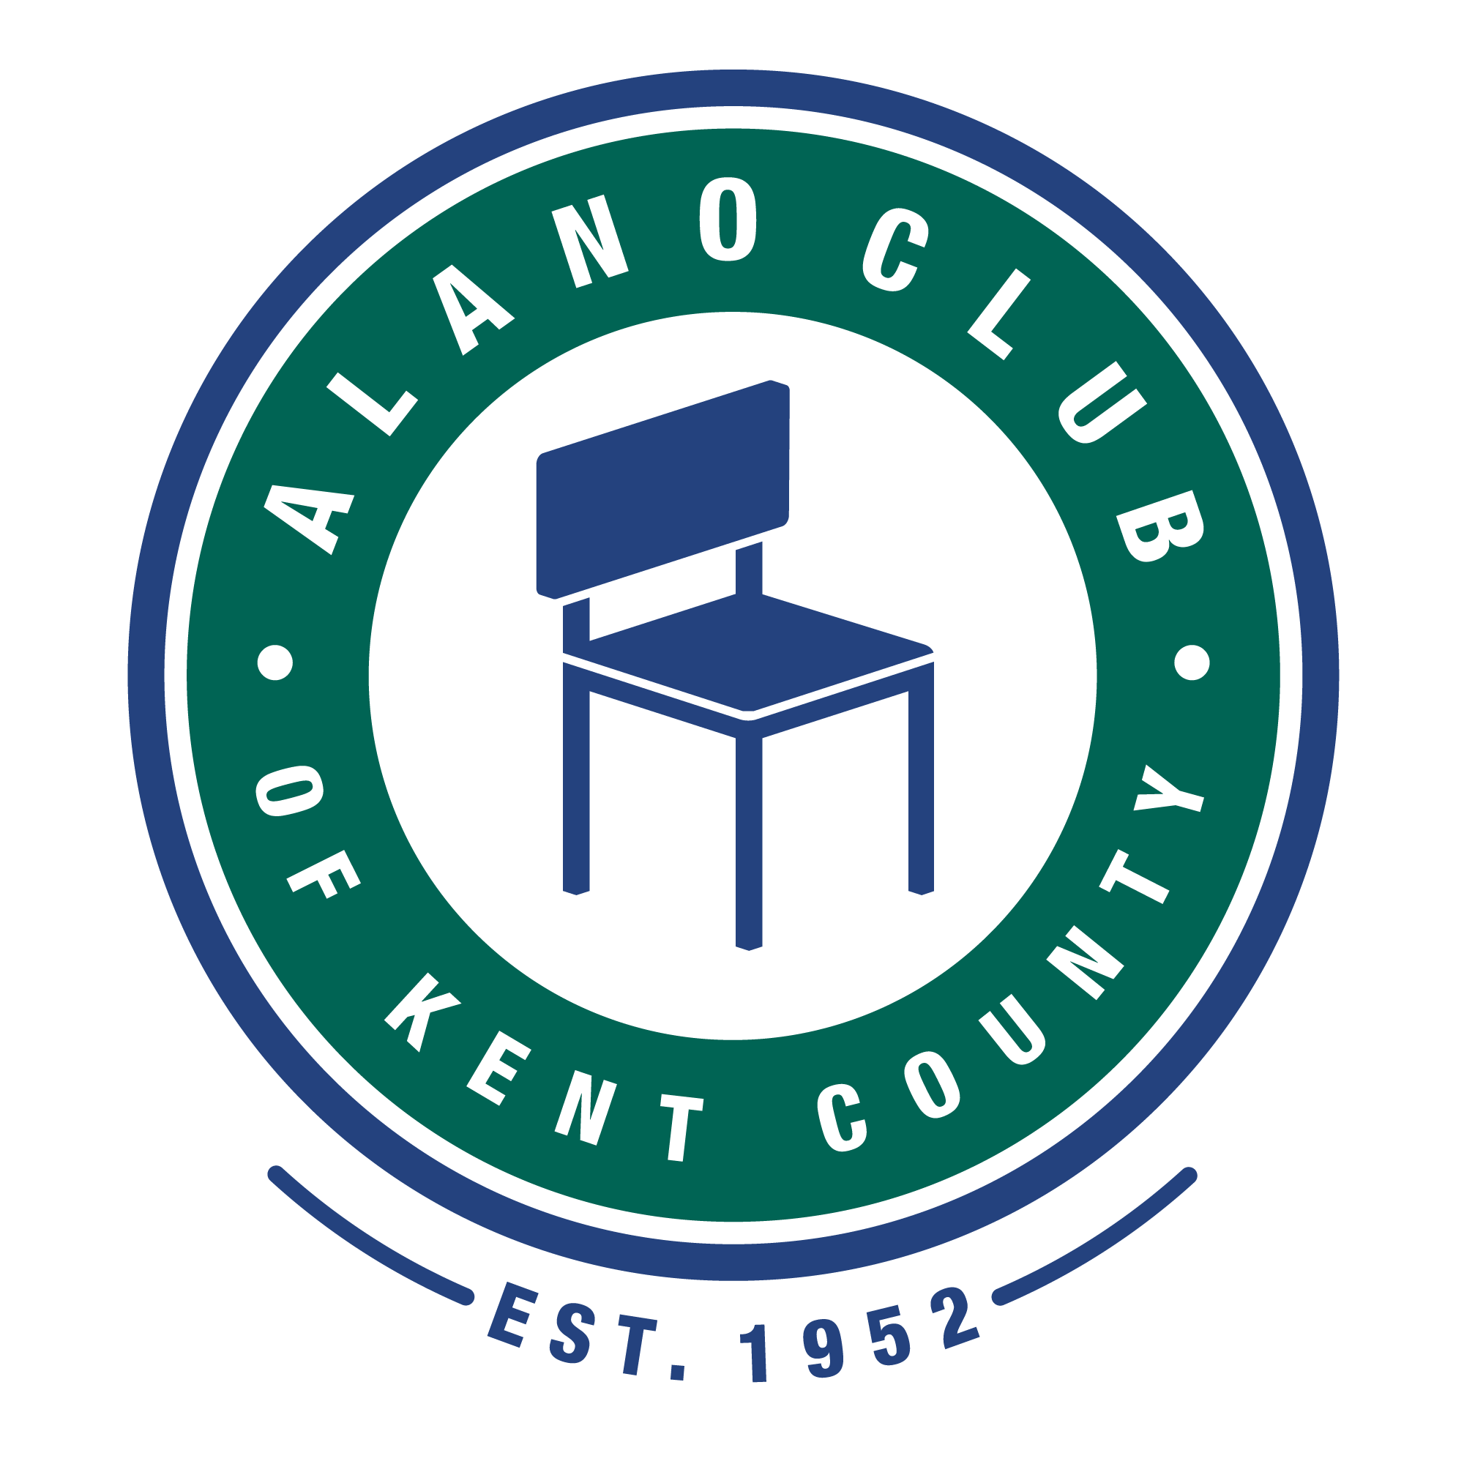
Meeting Date: 2/15/2022
Meeting Start: 5:30
Meeting Finish: 7:19 PM
Subject: Scheduled Board Meeting
Location: North Alano Club – Zoom
Prepared By: Ken Derylo
Attending: Elisha Ash (Chair), Mike Baker, Brad Rose (Vice Chair), Maggie Stalker, Ken Derylo (Secretary), Amelia Mueller (Treasurer), Lisa Derr (Executive Director), Mike Giusto,
Lauren Frazier, Don Nicewander

Absent: Erica Eldred, James Berg

Meeting Called To Order

Elisha called the meeting to order at 5:30pm and asked for a moment of silence followed by the
Serenity Pray.

Minutes Approval of the 12/21/21 Meeting

Mike B. motioned that the minutes from the 12/21/21 meeting be approved. This was seconded by Mike G. and were unanimously approved.

Reading of our Mission and Vision Statements

Elisha displayed and read both our Mission and Statements that the Board and the Club Staff need to support.

EXECUTIVED DIRECTOR UPDATE – LISA DERR

Financial Review

Lisa presented the latest financial (Profit & Loss) statement for December 2021 through January 2022. Revenues exceeded expenses and we had a net income of $15,534.49 for the period.

Lisa also provided a “Statement of Cash Flows” that shows we currently have $183,414.12 in checking and savings. The breakdown includes approximately 159,000.00 in checking and $25,000.00 in savings.

Lisa mentioned that food costs are a work in progress and, due to recent costs increases, what is charged members may have to be increased. Lauren F. mentioned that Gordon Foods has a tool that would help determine cost and the sale price.

Lisa reported that book sales are doing well. It was pointed out that book purchases by the Club were being made through KCCO and Hazleton.

Ken D. suggested that we should move some of the funds from the cash/checking account into the Endowment fund so we might get a better return. Amilia M. stated that the cash funds should remain outside of the Endowment fund as these funds were for Club operations and the endowment fund was setup for long term security. Brad R. suggested that the cash accounts be dived into 3 separate accounts. 1 for savings; 1 for future project; and 1 for operating. Amelia and Lisa will look into restructuring the accounts and make a recommendation on what’s a good way to go.

The financial report received unanimous approval.

Annual Budget

Lisa presented a budget document for the period beginning October 2021 through September 2022. There was very little discussion on this document other than Ken D. mentioned it was a good start on getting a budget done.

Membership Update

Lisa reported that Annual Memberships were up by 11 and monthly were up by 10. It was also mentioned that it was hoped that some of the events would hopefully attack new members.

Christmas Dinner & Euchre Tournament

It was reported that both events were well attended. The Euchre tournament had a $50.00 profit.

Other

It was pointed out that the dates for the Spring Table Host, May 20; the Golf Outing, July 30; and the Gala, October 4 were set and confirmed.

Lisa mentioned that Christy Buck of the Community Health Foundation would be the MC for the Round Table event. She also mentioned that once again the Golf Outing will be held at Scott Lake and that the guest speaker at the Gala will be Ken Daniels who, in addition to one of the founders of the Jamie Daniels Foundation, is the TV play by play announcer for the Detroit Red Wings.

BOARD CHAIR UPDATE - Elisha Ash

John Beal Memorial

Elisha reported that a small memorial service honoring John Beal was held at the North Alano Club. This event was attended by many members who knew and loved John.

A discussion followed regarding honoring long time members that have passed. One thought was to name rooms for these people another was to create a memorial wall with a plaque with the names of these past members. Lisa said she would look into a possible location for such a memorial. No decision was made

Increasing Visibility of the Alano Club

Elisha asked the Communications Committee to look into ways to increase the visibility of the Alano Club to the public and other organizations with an emphasis on what we are. Lauren F. and Mike B. to lead this effort.

Transparency

Elisha mentioned that Transparency is improving, and additional information is now being posted on the Club website. Elisha mentioned that a quarterly newsletter might be helpful.

Committees.

Elisha shared a document that outlined the responsibilities of the Governance, Events and Communications committees. She also stated that she would like to have each committee schedule meetings and create a plan for what they will accomplish.

Team Building

One of our former Board Presidents, Carla S., has offered to hold a team building event for board members and staff. The program is titled True Colors and that Elisha would like to schedule this before the end of April. The event would take place at the Club. She asked all to let her know if there were any availability issues.

Other

Ken D. mentioned that meeting minutes are not posted to the website until they are approved at the next board meeting. This means that the minutes are at least two months old before they get published. Ken requested that an electronic vote used to get these minutes posted sooner. It was determined that minutes would be posted, after an initial review, with a disclaimer stating that minutes posted are pending board approval. The disclaimer would be removed once approved.

Adjournment

Ken D. motioned that the meeting be adjourned and was seconded by Mike G. The meeting adjourned at 7:19 pm.

