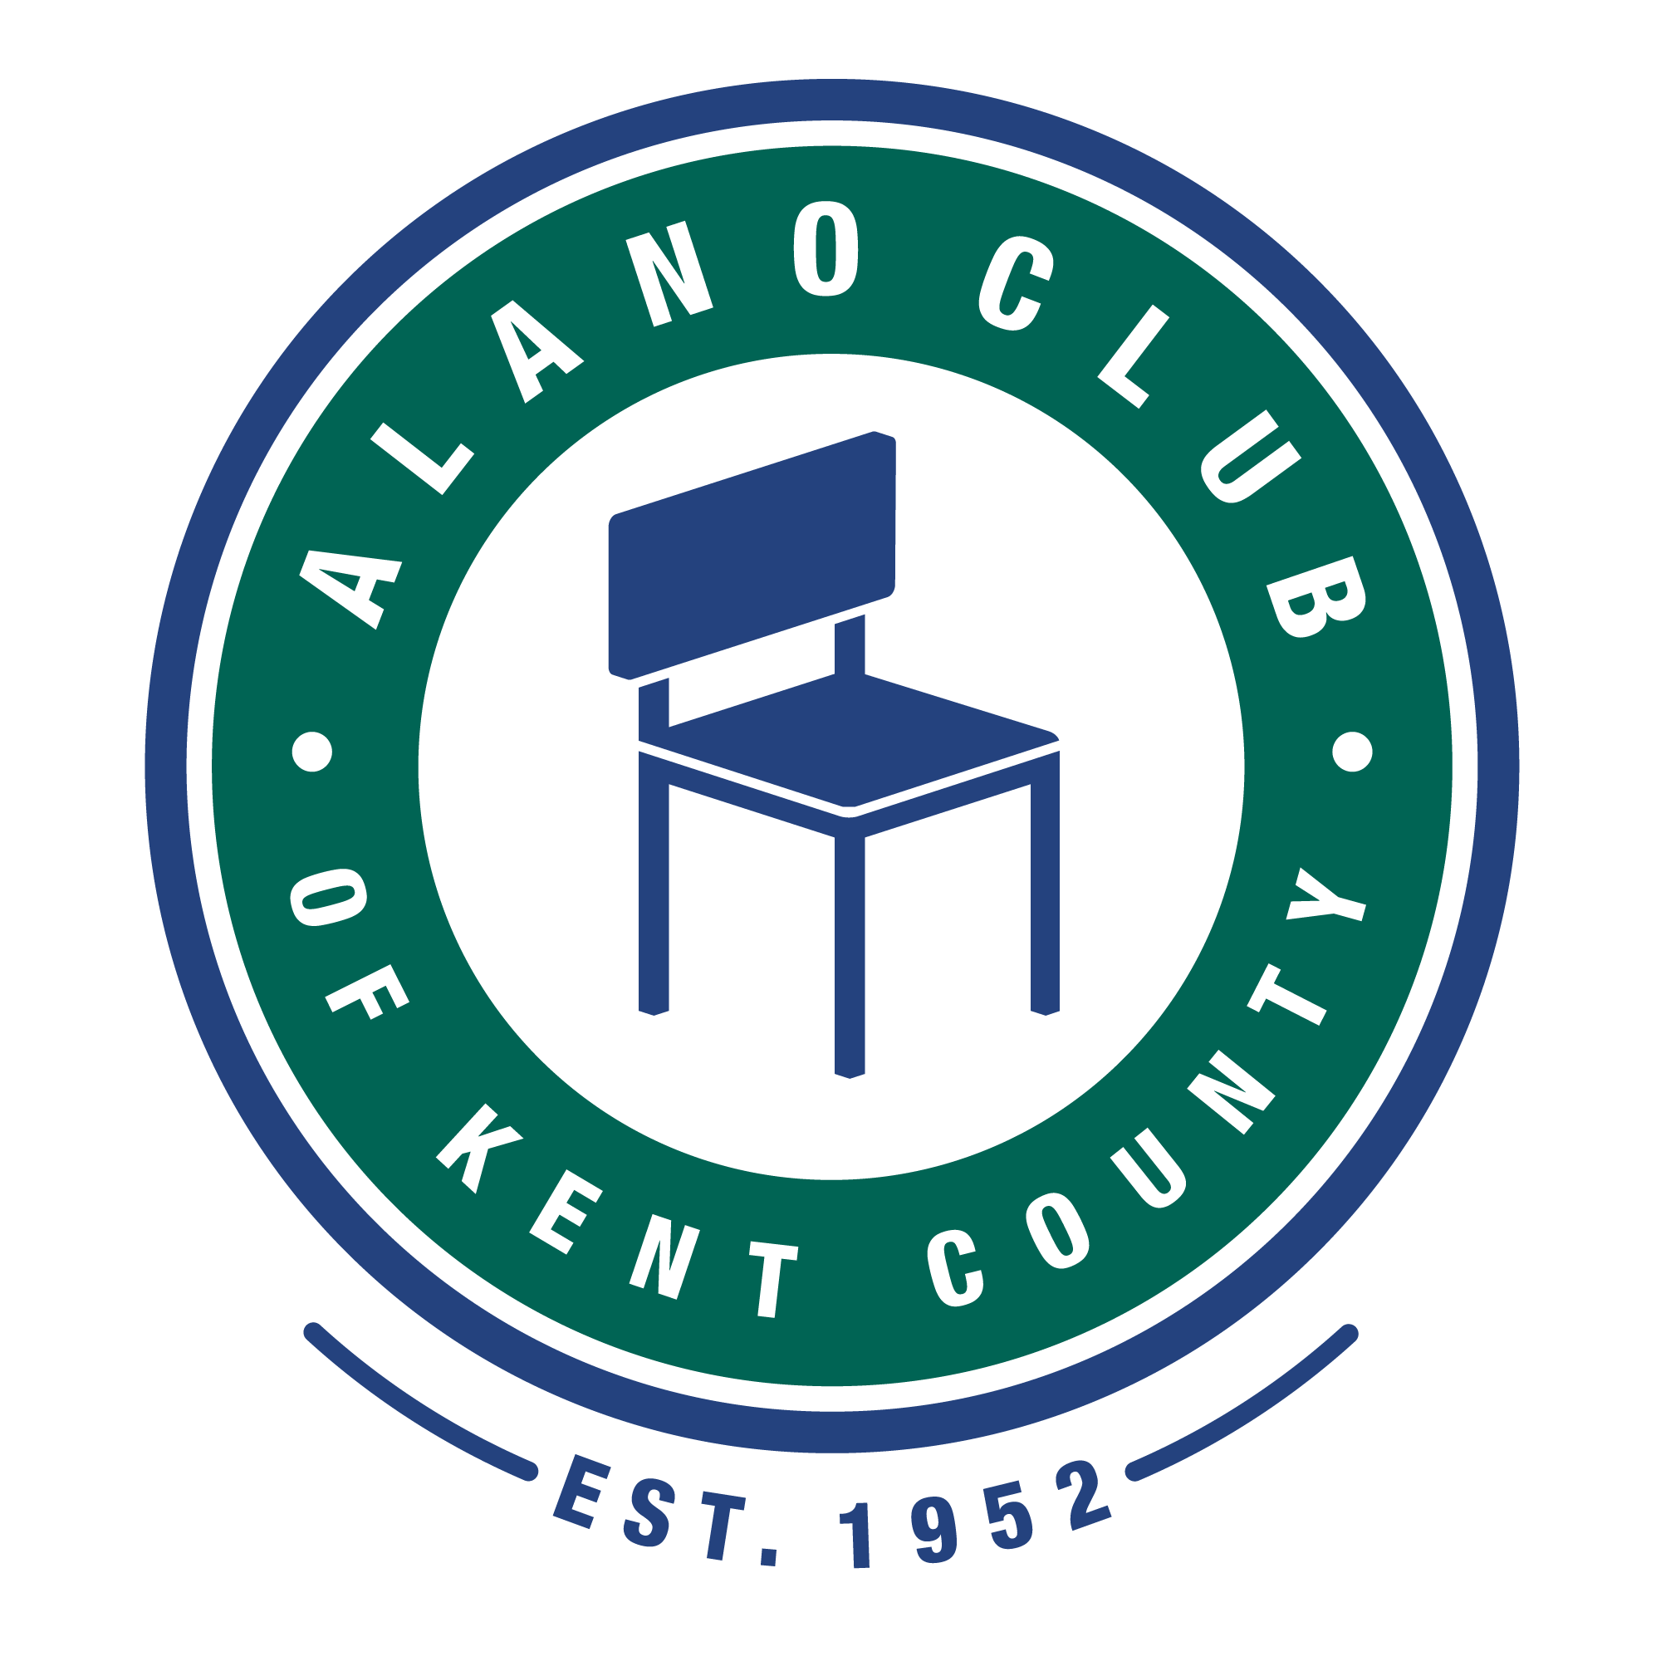
Meeting Date: 10/19/2021
Meeting Start: 5:45PM
Meeting Finish: 7:30PM
Subject: Scheduled Board Meeting
Location: North Alano Club – Room 2
Prepared By: Ken Derylo
Attending: Elisha Ash (Chair), Brad Rose (Vice Chair), Maggie Stalker, Ken Derlyo (Secretary), Amelia Mueller (Treasurer) and Lisa Derr (Executive Director)

Absent: Brent Doornbos, Mike Baker, Lauren Frazier, James Berg, Erica Eldred

Please Note: There were not enough board members present to form a quorum.

Meeting Called To Order

Elisha called the meeting to order at 5:45pm and asked for a moment of silence followed by the
Serenity Pray.

Minutes Approval of the 8/17/21 Meeting

Approval of the minutes was tabled. Ken said he would send them out to the board and ask them to approve. (Minutes have been approved by the board.)

Financial Review

Lisa presented the latest financial (Profit & Loss) statement for August and September. Lisa pointed out that food lost $351.15 which was a significant improvement since the last report. The staff will continue to work to make food profitable.

Because there was no quorum the approval of the financial report was tabled until the next board meeting.

Annual Budget

Lisa and Amelia continue to work on the annual budget. Hopefully this will be ready for approval by the December meeting.

Bylaws Update

Maggie mentioned that the bylaw rewrite .was still not complete but she expected to have them finished by the next board meeting.

Gala Update

Lisa gave an update on the Gala that included a financial statement. The statement showed that there was a net gain of $18.332.96.
The question of the ticket price increase was also discussed, and it was mentioned that the increase was due to cost increases for the event. It was also mentioned that not having a plated dinner was due to staffing issues at GVSU.

Posting Financials on the Website

Amelia and Lisa will meet to discuss a format for posting the financial statement on the club website.

New Staff Member

Lisa mentioned that Tim started on August 31 and his probation period will be up on November 30. Lisa mentioned that he is working out very well and would like to put him on salary. In addition to his fund raising activities, Tim will begin to input room rent in Kindful. This will start in January. Brad Rose stated that he will look into exporting Xcel into Kindful as this could save some time.

Annual Membership Meeting

The annual membership meeting is scheduled on November 13, 2021 from 1:30 – 3:00 pm and will include the annual election. It was pointed out that there is one opening on the board and that nominations would be closed on October 23.

Membership Drive

A membership drive will be held after the Annual Membership Meeting.

Town Hall Meeting

The Town Hall Meeting was briefly discussed and included an overview of what was brought up by Leonard M., Michelle B. and Hailey. (Please see the Town Hall Meeting recap.)

Exit Interviews

Of the exit interviews that were requested only Nick S. replied.

Improved Transparency

Not much discussed on this topic. It will remain on future meeting agendas.

Meeting adjourned at 7:30 pm.

Next meeting is scheduled for December 21, 2021 at the North Alano Club 5:30 – 7:30 pm.

